
Approved by the AICTE (F.No.06/07/MS/ENGG/2004/029), DTE(2NGC/2004/Mantralaya/7) & Affiliated to Nagpur University (NAVI/MVI/04/694/S/158)
(Managed by The Nagpur Pallottine Society)
Accredited by NAAC with ‘A’ Grade Post Box No. 128, G.P.O. Nagpur 440001
DEPARTMENT OF COMPUTER SCIENCE & BUSINESS SYSTEMS
Assignment 2

Course: Design and Analysis of Algorithms Course Code: 24CB501T
Semester: 5th Year: 3rd
UID: 23016027 Student Name: Shravan Vijay Sapate
Faculty Name: Prof. Pradnya S. Moon

Title: Case Study – FRIEND SUGGESTIONS USING GRAPH CLUSTERING

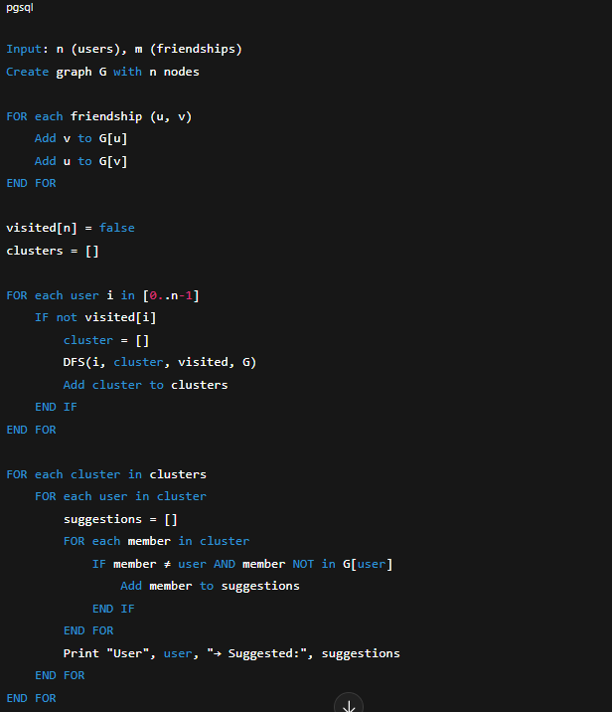
Pseudo Code

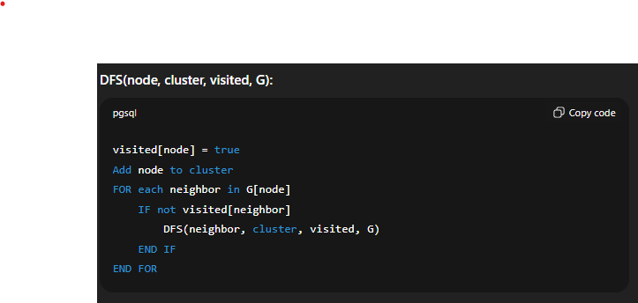

Example Input:
n = 5, m = 3 Edges: 0–1
1–2
3–4

Step 1: Graph
User | Friends
0 | 1
1 | 0, 2
2 | 1
3 | 4
4 | 3

Step 2:
Step | Node | Cluster Formed | Visited
1 | 0 | [0,1,2] | ✓✓✓□□
2 | 3 | [3,4] | ✓✓✓✓✓
Clusters → [0,1,2], [3,4]

Step 3:
Friend Suggestions
User | Direct Friends | Suggestions
0 | 1 | 2
1 | 0,2 | –
2 | 1 | 0
3 | 4 | –
4 | 3 | –

Final Output:
User 0 → Suggested: 2
User 1 → No new suggestions
User 2 → Suggested: 0
User 3 → No new suggestions
User 4 → No new suggestions

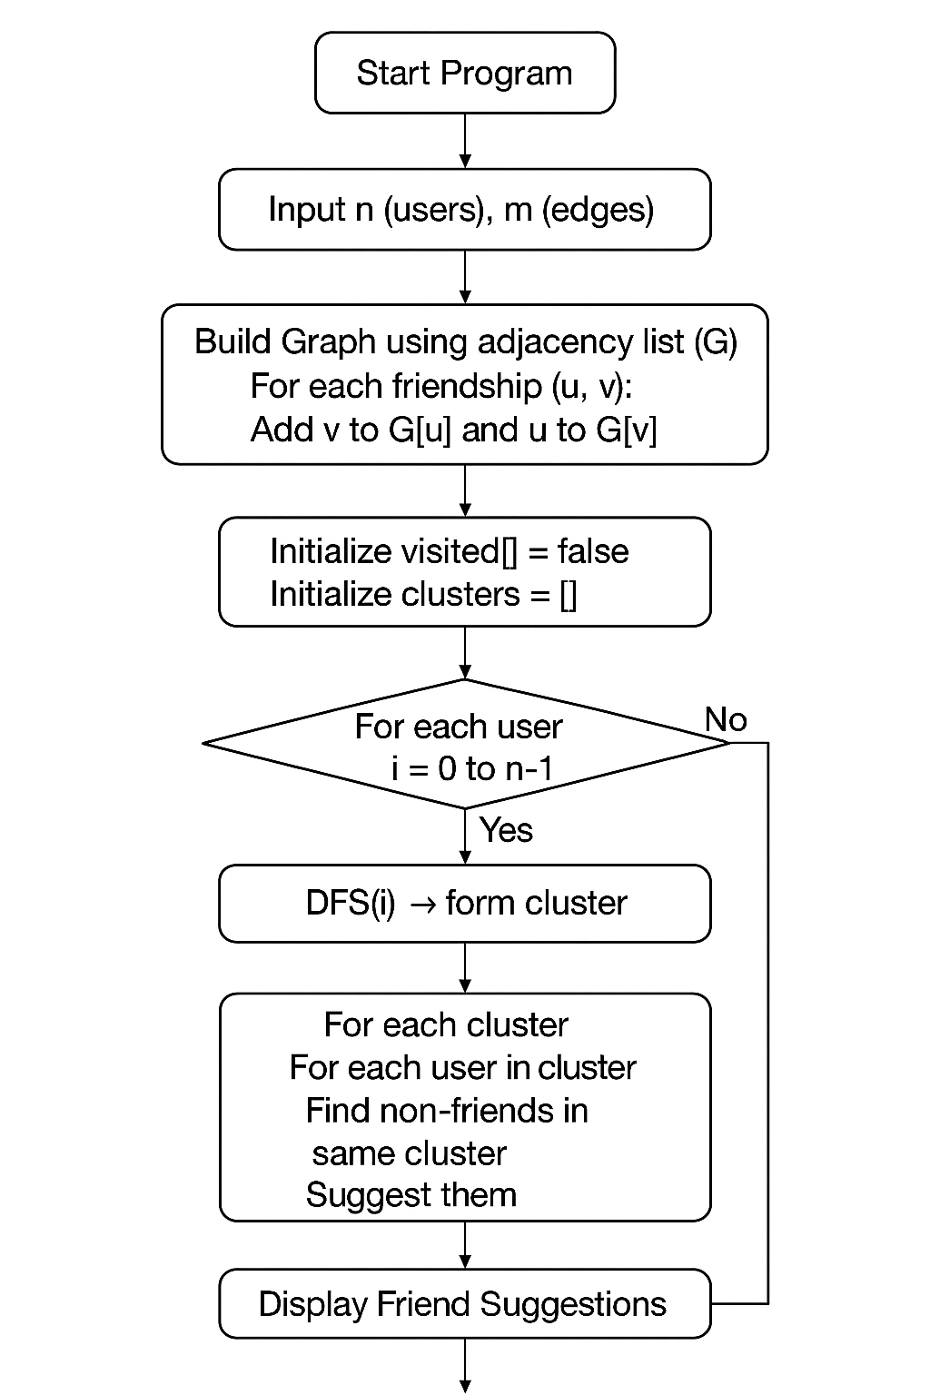
Flow Chart:

Variables
- n, m → users & friendships
- G[] → adjacency list
- visited[] → DFS visit tracker
- clusters → list of user groups
- suggestions → recommended friends

Behavior
- Build graph → DFS to form clusters
- For each user in a cluster → suggest non-direct friends

For Each Edge
Add edge (u, v)
Add edge (v, u)

Stopping Condition
All users visited (DFS complete)

Output
Friend suggestions for each user in same cluster
e.g.
User 0 → Suggested: 2

Complexities
- Time: O(n + m) (sparse) or O(n²) (dense)
- Space: O(n + m)

